

**Research & Vehicle Technology**

**“Infotainment Systems Product Development”**

**Feature – NAV Repeater V2**

**APIM Infotainment Subsystem Part Specific Specification (SPSS)**

Version 1.2

**UNCONTROLLED COPY IF PRINTED**

**Version Date:  November 4, 2016**

**FORD CONFIDENTIALF**

**Revision History**

|  |  |  |  |
| --- | --- | --- | --- |
| **Date** | **Version** | **Notes** | |
| May 30, 2013 | 1.0 | **Initial Release** | |
|  |  |  | |
| July 18, 2014 | 1.1 | **Updated Release** |  |
|  |  | NAVREPEATv2-IIR-REQ-022889/B-Navigation Repeater Server Signals (TcSE ROIN-281280-1) | rpaquet2 - Added UpcomingStreetName.St |
|  |  | STR-070086/B-Functional Definition (TcSE ROIN-294192-1) | Added new function for Detailed Intersection Widgits |
|  |  | NAVREPEAT-FUN-REQ-092269/A-Detailed Intersection Widgit | New function |
|  |  | NAVREPEAT-UC-REQ-092268/A-Detailed Intersection Widgit | New use case |
|  |  | EH-FUR-REQ-092267/A-Detailed Intersection Widgit | <wstephe1> Requirement added by rpaquet2for EH related to NavRepeater (See requirement text) |
| November 4, 2016 | 1.2 | **Updated Release** |  |
|  |  | NAVREPEAT-FUN-REQ-232516/A-Sending StreetName signals | initial release |
|  |  | NAVREPEAT-FUN-REQ-232923/A-Street Name String Truncation | initial release |
|  |  | NAVREPEATv2-IIR-REQ-022889/B-Navigation Repeater Server Signals (TcSE ROIN-281280-1)+ | rpaquet2 - Added UpcomingStreetName.St |
|  |  | NAVREPEATv2-IIR-REQ-022889/C-Navigation Repeater Server Signals (TcSE ROIN-281280-1) | rpaquet2 - Added StreetName2_St and CurrentStreetName2_St to allow for 80 characters |
|  |  | MD-REQ-232926/A-StreetName2_St | initial release |
|  |  | MD-REQ-232927/A-CurrentStreetName2_St | initial release |
|  |  | NAVREPEAT-SR-REQ-022827/B-NavigationSymbolInfo.St - DistanceToNextManeuver rounding for display purposes (TcSE ROIN-285754-2) | rpaquet2 - Added text to clarify that Meter/Yards/Feet are not rounded but displayed as sent by the server. |

**Table of Contents**

STR-070086/B-Functional Definition (TcSE ROIN-294192-1) 2

Added new function for Detailed Intersection Widgits 2

NAVREPEAT-FUN-REQ-092269/A-Detailed Intersection Widgit 2

New function 2

1 Architectural Design 4

1.1 NAVREPEAT-CLD-REQ-022852/A-Navigation Repeater Server (TcSE ROIN-150516-3) 4

1.1.1 Requirements 4

1.2 Interface Requirements 5

1.2.1 NAVREPEAT-IIR-REQ-022790/A-Navigation Repeater Client Signals (TcSE ROIN-149266-1) 5

1.2.2 NAVREPEATv2-IIR-REQ-022889/C-Navigation Repeater Server Signals (TcSE ROIN-281280-1) 6

2 Functional Definition 17

2.1 NAVREPEAT-FUN-REQ-022791/A-Browse Navigation (TcSE ROIN-294096-1) 17

2.1.1 Use Cases 17

2.1.2 Requirements 18

2.1.3 Sequence Diagrams 18

2.2 NAVREPEAT-FUN-REQ-022797/A-Display Route not Active Home Screen (TcSE ROIN-294099-1) 19

2.2.1 Sequence Diagrams 20

2.3 NAVREPEAT-FUN-REQ-022799/A-Display Route Active Home Screen (TcSE ROIN-294101-1) 20

2.3.1 Use Cases 21

2.3.2 Requirements 22

2.3.3 Sequence Diagrams 42

2.4 NAVREPEAT-FUN-REQ-022829/A-Repeat Guidance, Route Active (TcSE ROIN-294105-1) 44

2.4.1 Use Cases 44

2.4.2 Sequence Diagrams 44

2.5 NAVREPEAT-FUN-REQ-022832/A-Cancel Active Route (TcSE ROIN-294107-1) 45

2.5.1 Use Cases 45

2.5.2 Sequence Diagrams 45

2.6 NAVREPEAT-FUN-REQ-022835/A-Cancel Current Active Waypoint (TcSE ROIN-294109-1) 46

2.6.1 Use Cases 46

2.6.2 Sequence Diagrams 47

2.7 NAVREPEAT-FUN-REQ-092269/A-Detailed Intersection Widgit 47

2.7.1 Use Cases 47

2.7.2 Requirements 48

3 Appendix: Reference Documents 49

# Architectural Design

## NAVREPEAT-CLD-REQ-022852/A-Navigation Repeater Server (TcSE ROIN-150516-3)

Responsibility: The Navigation Repeater Server is the interface to the Navigation Client for the Navigation function.  It responds to requests from the Navigation Client during List Browse requests.  It also provides route information, next maneuver indicators, and status messages to the Navigation Client.

### Requirements

#### NAVREPEAT-SR-REQ-022853/A-Format for DistanceToNextManeuver parameter (TcSE ROIN-221180-1)

The Navigation Repeater Server shall use the Nav Repeater Format configuration bit to determine what format (Motorola vs. INTEL) to code the DistanceToNextManeuver paramter in the NavigationSymbollInfo.St TP signal.

Example of formating

DistanceToNextManeuver = 1.2 miles with PropertyOfDistance = length

INTEL Format :              Byte 2 = $0C, Byte 3 = $00

Motorola Format :         Byte 2 = $00, Byte 3 = $0C

#### NAVREPEAT-SR-REQ-022848/A-Event Periodic TP signals (TcSE ROIN-197787-1)

The following TP signals shall be sent every four (4) seconds, even if there is no change in the data that is being sent: NavigationSymbolInfo.St, CurrentStreetName.St, and StreetName.St.  If any data changes within these signals in between the four (4) second period, the signal shall be updated and sent out immediately with these changes.

#### NAVREPEAT-FUN-REQ-232516/A-Sending StreetName signals

The Navigation Repeater Server shall transmit the new StreetName2_St, CurrentStreetName2_St and UpcomingStreetName2_St first followed by the old StreetName_St, CurrentStreetName_St and UpcomingStreetName_St signals.

#### NAVREPEAT-FUN-REQ-232923/A-Street Name String Truncation

The Navigation Repeater Server shall transmit a truncation character if the string contains more characters then the corresponding ISO-TP signal is able to transmit. The last possible character within the string shall be replaced with a truncation character.

The Navigation Repeater Server shall use UTF16 character 0x2026 as truncation character (refer to attached extract from UTF16 codepage).

Example:

Street Name string size: 36 char “Andrew Young International Boulevard”

Street Name signal string size: 30 char “Andrew Young International Bou”

Street Name transferred: 30 char “Andrew Young International Bo…”

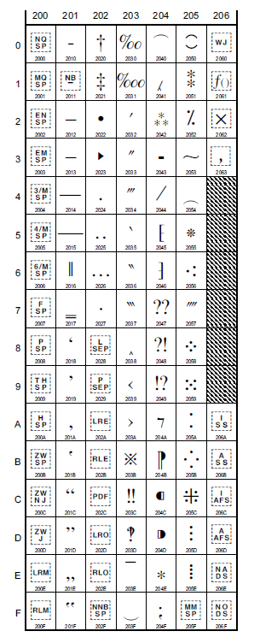

(UTF16 Codepage extract General Punctuation)

## Interface Requirements

### NAVREPEAT-IIR-REQ-022790/A-Navigation Repeater Client Signals (TcSE ROIN-149266-1)

|  |  |  |
| --- | --- | --- |
| **Method** | **Notes** | **Parameters** |
| **CancelCurrentWaypoint.Rq()** | Message Type : Request    Method from Navigation Repeater Client to Navigation Repeater Server to request that current active waypoint be cancelled.  Route remains active. | int *CancelWaypoint*  0x0 Inactive  0x1 Cancel |
| **CancelRoute.Rq()** | Message Type : Request    Method from Navigation Repeater Client to Navigation Repeater Server to request that current active route be cancelled.  This would also cancel any waypoints that are also active. | int *CancelRoute*  0x0 Inactive  0x1 Cancel |
| **Guidance_Repeat.Rq()** | Message Type: Request    Method from Navigation Repeater Client to Navigation Repeater Server.  Signal that tells Navigation Repeater Server to repeat the last voice guidance prompt. | int *RepeatGuidance*  0x0 Inactive  0x1 Active |

### NAVREPEATv2-IIR-REQ-022889/C-Navigation Repeater Server Signals (TcSE ROIN-281280-1)

|  |  |  |
| --- | --- | --- |
| **Method** | **Notes** | **Parameters** |
| **CancelCurrentWaypoint.Rsp()** | Message Type : Response    Response message from Navigation Repeater Server to Navgation Repeater Client, stating that current waypoint was cancelled. | int *CancelWaypoint*  0x0 Inactive  0x1 Cancelled |
| **CurrentStreetName.St()** | Message Type : Status    Description: This attribute shows the name of the current street that the vehicle is driving on. It is sent over the ISO 15765-2 protocol.    It also provides the numerical value of the speed limit  if there is one for the current street.  This value can be from 1 to 255.  Units are not provided. | int *DataUpdate*  0x0 Inactive  0x1 Set Operation  0x2 Data refresh    string *CurentStreetName*  20 characters max    int *SpeedLimit*  0x00 Invalid  0x01 1  ...  0xFF 255 |
| **Destination_Info.St()** | Message Type : Status    TP signal which contains information about the destination or waypoint.  The signal is provided from the Navigation Repeater Server to the Navigation client.  The signal is sent upon Destination / waypoint arrival.  If any strings are longer than 19 Characters + EOS the data is truncated.    It is sent over the ISO 15765-2 protocol. | int *TotalDistTraveled*  0x0  ...  0xFFFF  Note:  TotalDistTraveled units are in steps of 0.1 miles/kilometers  Ex. 0x0005 = 0.5 miles/kilometers    int *DistUnits*  0x0 Miles  0x1 Kilometres    int *TotalTime*  0x0  ...  0xFFFF  { units is minutes }    string *Destination*  19 Characters Max |
| **DistanceToDestination.St()** | Mesage Type: Status    This attribute shows the remaining distance to destination to the infotainment displays.    $0: Kilometers [km]  $1: Meters [m]  $2: Miles [mi]  $3: Yards [yd]    For North America market, this parameter shall be sent out in feet by the Server, and the encoding shall be $3 – yards.  The Client shall know to display the distance in feet based on the configuration (NA America).  For FoE markets, this parameter shall be sent out in yards by the Server, and the encoding shall be in $3 – yards. | int *Distance*  Size: 2 byte  Values:  0x0000 .. 0xFFFD: Distance (0 .. 65533)  0xFFFE: Distance not available  0xFFFF: Invalid  Note: Distance units are in steps of 0.1 miles/kilometers  Ex. 0x0005 = 0.5 miles/kilometers      int *Unit :*  Size: 2 bit  Values:  $0: Kilometers [km]  $1: Meters [m]  $2: Miles [mi]  $3: Yards [yd] |
| **GPS_Compass_direction.St()** | Message Type : Status    Message from GPS Server.  Current compass position is returned to Navigation Client. | int *Direction*  0x0 North  0x1 Northeast  0x2 East  0x3 Southeast  0x4 South  0x5 Southwest  0x6 West  0x7 Northwest |
| **NavError.St** | Message Type : Status    Message from Navigation Server to Navigation Client reporting status of Navigation System Errors. | Int *ErrorStatus*  0x0 Invalid  0x1 No Error  0x2 Navigation_Fault |
| **NavigationSymbolInfo.St()** | Message Type: Status    This method is used to display the navigation recommendations in the repeater display. The TP signal NavigationSymbolInfo_St has to be set with all information and values in all cases. The supported symbols are shown in the requirements.    For North America market, the HeaderInfo Unit of Length parameter shall be sent out in feet by the Server, and the encoding shall be $3 – yards.  The Client shall know to display the distance in feet based on the configuration (NA America).  For FoE markets, this parameter shall be sent out in yards by the Server, and the encoding shall be in $3 – yards.    The message is transferred using the ISO 15765-2 transport protocol. | int *HeaderInfo*  Bitfield:  Bit 7: Property of distance  ($0: bargraph, $1: length)  Bits 5-6: Unit of Length  ($0: kilometres, $1: miles, $2: metres, $3: yards)  Bits 0-4 Reserved  The values 0x2 and 0x3 of the UnitOfLength shall only be used for Gen3 and Gen 3.1 systems.    int *DistanceToNextManeuver*  Values:  $0000 .. $FFFF:  If the "PropertyOfDistance" is set to "length", the "DistanceToNextManeuver" shall be in steps of 0.1 kilometres / miles.  Ex. 0x0005 = 0.5 miles/kilometers    If the "PropertyOfDistance" is set to "bargraph", the "DistanceToNextmaneuver" shall be in steps of 0.01 kilometres / miles.  Ex. 0x0005 = 0.05 miles/kilometers    If the "UnitOfLength" is set to "metres" or "yards", the "DistanceToNextManeuver" shall be in steps of 5 metres / yards.    int *BargraphSteps*  Values:  $00 .. $FF:  The relative size of the bargraph is defined in the range from 0x00 = 0% up to 0xFF = 100%.  The BargraphSteps value decreases from 0xFF at start down to 0x00 when the decision point is reached.    int *NumberOfStreetSegments*  Value:  $01 .. $14    int *DirectionAndNumbers*  0x00 North  0x01 1  0x02 2  0x03 3  0x04 4  0x05 5  0x06 6  0x07 7  0x08 8  0x09 9  0x10 North - North - West  0x20 North - West  0x30 West - North - West  0x40 West  0x50 West - South - West  0x60 South - West  0x70 South - South - West  0x80 South  0x90 South - South - East  0xA0 South - East  0xB0 East - South - East  0xC0 East  0xD0 East - North - East  0xE0 North - East  0xF0 North - North - East  0xFF No direction    int ManeuverElement  0x00  NoSymbol (NO_SYMBOL)  0x01  SideStreet (SIDESTREET)  0x02  Silent (SILENT)  0x03  Turn (TURN)  0x04  UTurnTrafficRightSide  (U_TURN_TRS_RIGHT)  0x05  UTurnTrafficLeftSide  (U_TURN_TRS_LEFT)  0x06  ChangeLane (FILTER)  0x07  ServiceRoad (PARALLEL_CWY)  0x08  ServiceRoad (SERVICE ROAD)  0x09  Fork (ORIENTATE)  0x0A  Exit (EXIT)  0x0B  TurnOnMainroad (MAINROAD)  0x0C  RoundaboutTrafficRightSide  (ROUNDABOUT_TRS_RIGHT)  0x0D  RoundaboutTrafficLeftSide  (ROUNDABOUT_TRS_LEFT)  0x0E  SquareTrafficRightSide  (SQUARE_TRS_RIGHT)  0x0F  SquareTrafficLeftSide  (SQUARE_TRS_LEFT)  0x10  NoInfo (NO_INFO)  0x11  FollowStreet  (FOLLOW_STREET)  0x12  ChangeLane  (PREPARE_TURN)  0x13  ArrivedAtDestination  (DEST_REACHED)  0x14  ArrivedAtWaypoint  0x15  ApproachingDestination  0x16  ApproachingWaypoint  0x17  EnterHighway  0x18  FerryAhead  0x19  Merge  0x20  OffRoad (OFF_ROAD)  0x21  OffMap (OFF_MAP)  0x22  NoRoute (NO_ROUTE)  0x23  CalcRoute  (CALC_ROUTE)  0x24  ArrivedDestinationOffMap  (DEST_AREA)  0x25  RecalcRoute  (RECALC_ROUTE)  0x30  Number (NUMBER)    ArrayType *Array*  Array(1.. NumberOfStreetSegments) of record (DirectionAndNumbers, ManeuverElement) |
| **RemainTimeToDestination.St()** | Mesage Type: Status    This attribute shows the remaining time to destination to the infotainment displays. | Int *Days:*  Size: 4 bit  Values:  0x0…0xD days (0..13)  0xE Greater than 13 days    int *Hours :*  Size: 5 bit  Values:  0x00 .. 0x18: Hours (0 .. 24)  0x1E: Not available  0x1F: Invalid    int *Minutes :*  Size: 6 bit  Values:  0x00 .. 0x3C: minutes (0 .. 60)  0x3D .. 0x3D: reserved  0x3E             : not available  0x3F             : invalid |
| **RouteActive.St()** | Message Type : Status    Method from Navigation Repeater Server to Navigation Repeater Client.  Reports Status of Route. | int *RouteActive*  0x0 Not Active  0x1 Active |
| **StreetName.St()** | Message Type: Status    This method is used to display street name in the text area of the Navigation repeater display. The current street name shall be displayed if the recommendations "Follow Street" is sent (GEN 3.0 only). In all other cases the following street name shall be displayed. The full street name shall be sent, truncation is up to the display.    The message is transferred using the ISO 15765-2 transport protocol. | int *Attribute*  Text alignment  0x0  centered  0x1  left aligned  0x2  right aligned  The text alignment bit shall only be used for Gen2 systems and ignored on all Gen3 and Gen3.1 systems.    int *StreetName*  Values:  Bytes 0 .. 20: StreetName |
| **WaypointsActive.St()** | Message Type : Status    Message from Navigation Repeater Server to Navigation Repeater Client reporting status of waypoints.  If Max_Waypoints_Active is set, the Navigation Repeater Client shall disallow setting another Waypoint. | int *WaypointStatus*  0x0 Invalid  0x1 Waypoints_Inactive  0x2 Waypoints_Active  0x3 Max_Waypoints_Active |
| **UpcomingStreetName.St()** | Message Type : Status    Description: This attribute shows the name and/or Road Shield data of the defined intersecting stub that is expanded via the Electronic Horizon Server. It is sent over the ISO 15765-2 protocol. | int *Path Index*  0x0 – 0x7 = Reserved  0x8 – 0x63 = IndexOfPath  int *Stub Path Index*  0x0 StubStartsFirstPathInHorizon  0x1 – 0x7 Reserved  0x8 – 0x63 SubIndexOfPath  int *Road Shield Icon*  1 Byte See Coding table  string *RoadshieldText*  9 characters max  string *UpcomingStreetNameText*  20 characters max |

#### MD-REQ-232926/A-StreetName2_St

Message Type: Status

This method is used to display street name in the text area of the Navigation repeater display. The current street name shall be displayed if the recommendations "Follow Street" is sent (GEN 3.0 only). In all other cases the following street name shall be displayed.

|  |  |  |  |
| --- | --- | --- | --- |
| **Name** | **Literals** | **Value** | **Description** |
| TextAlignment | - |  | The text alignment bit shall only be used for Gen2 systems and ignored on all Gen3 and Gen3.1 systems. |
|  | Centered | 0x0 |  |
|  | Left Aligned | 0x1 |  |
|  | Right Aligned | 0x2 |  |
|  |  |  |  |
| StreetName | - |  | Parameter StreetName is used to transmit the street name string to the Client. |
|  | String | - | StreetName up to 81 characters. 80 letters plus 1 EOS character |

#### MD-REQ-232927/A-CurrentStreetName2_St

Message Type: Status

This status signal will be used to transmit the name of the current street that the vehicle is driving on from the NavigationRepeaterServer to the NavigationRepeaterClient.

|  |  |  |  |
| --- | --- | --- | --- |
| **Name** | **Literals** | **Value** | **Description** |
| DataUpdate | - |  | Data update is used to indicate if new data is incoming or if the currently shown data shall be updated. |
|  | Inactive | 0x0 |  |
|  | Set Operation | 0x1 |  |
|  | Data refresh | 0x2 |  |
|  |  |  |  |
| SpeedLimit | - |  | The parameter SpeedLimit is used to transmit the speed limit on the current street the vehicle is driving on. |
|  | Invalid | 0x00 |  |
|  | 1 | 0x01 |  |
|  |  | … |  |
|  | 255 | 0xFF |  |
|  |  |  |  |
| CurrentStreetName | - |  | Parameter CurrentStreetName is used to tranmit the street name string to the Client. |
|  | String | - | CurrentStreetName up to 81 characters. 80 letters plus 1 EOS character |

# Functional Definition

## NAVREPEAT-FUN-REQ-022791/A-Browse Navigation (TcSE ROIN-294096-1)

### Use Cases

#### NAVREPEAT-UC-REQ-022792/A-Quick Navigation Browse (TcSE ROIN-292751-1)

|  |  |
| --- | --- |
| **Actors** | User |
| **Pre-conditions** | User currently on the Route not Active home screen in the Cluster OR Active Route Options Menu within the Navigation Cluster HMI screens. |
| **Scenario Description** | The user enters quick browse to view a list. |
| **Post-conditions** | List of available items shown |
| **List of Exception Use Cases** | N/A |
| **Interfaces** | Vehicle System Interface  G-HMI |

#### NAVREPEAT-UC-REQ-022793/A-Destination Selection (TcSE ROIN-292752-1)

|  |  |
| --- | --- |
| **Actors** | User |
| **Pre-conditions** | List browse is active  List of valid destinations active |
| **Scenario Description** | User selects destination |
| **Post-conditions** | Exit browse and show navigation home screen |
| **List of Exception Use Cases** | N/A |
| **Interfaces** | Vehicle System Interface  G-HMI |

#### NAVREPEAT-UC-REQ-022794/A-Waypoint Selection (TcSE ROIN-292753-1)

|  |  |
| --- | --- |
| **Actors** | User |
| **Pre-conditions** | Route is active  Browse is active  List of valid waypoints active |
| **Scenario Description** | User selects waypoint |
| **Post-conditions** | Navigation home screen |
| **List of Exception Use Cases** | N/A |
| **Interfaces** | Vehicle System Interface  G-HMI |

### Requirements

#### NAVREPEAT-SR-REQ-022795/A-List Browse- Set Operation (TcSE ROIN-159114-1)

While in the Quick Navigation list Browser, if there is no child list available for current list, the browser shall issue a SetLBPItem.Rqcommand to the Navigation Repeater Server.

The Navigation Repeater Server shall then respond to this SetLBPItem.Rq by issuing a CurrentStreetName.St TP message, with Set Operation encoding for the DataUpdate parameter.

This shall trigger the Navigation Repeater Client to update the HMI of the display to the Route Active home screen.

### Sequence Diagrams

#### NAVREPEAT-SD-REQ-022796/A-Quick Navigation Browse (TcSE ROIN-118701-1)

Scenarios

Normal Usage

The user enters < Quick Navigation List Browser > to select a new destination / waypoint from the cluster HMI.

Constraints

Pre-condition

User currently on the Route not Active home screen in the Cluster OR Active Route Options Menu within the Navigation Cluster HMI screens.

Post-condition

User has exited browse, and returns to Navigation home screen.

Sequence Diagram

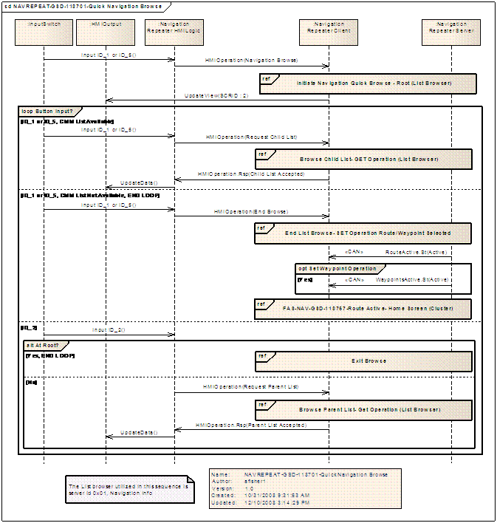

## NAVREPEAT-FUN-REQ-022797/A-Display Route not Active Home Screen (TcSE ROIN-294099-1)

### Sequence Diagrams

#### NAVREPEAT-SD-REQ-022798/A-Route Not Active - Home Screen (TcSE ROIN-118771-2)

**Linked Elements**

NAVREPEAT-FUN-REQ-022797/A-Display Route not Active Home Screen (TcSE ROIN-294099-1)

Scenarios

Normal Usage

User is viewing route not active home screen on the right hand side cluster display.

Constraints

Pre-condition

{The Navigation route not active home screen} is displayed via cluster HMI.

Post-condition

{The Navigation route not active home screen} is displayed via cluster HMI.

Sequence Diagram

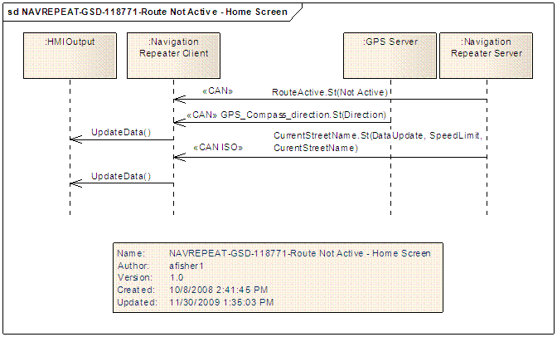

## NAVREPEAT-FUN-REQ-022799/A-Display Route Active Home Screen (TcSE ROIN-294101-1)

### Use Cases

#### NAVREPEAT-UC-REQ-022800/A-Show Destination Reached Symbol (TcSE ROIN-292743-1)

|  |  |
| --- | --- |
| **Actors** | System |
| **Pre-conditions** | The navigation system is active.  A route is computed and guidance is active.  The map database is available.  The navigation system is able to provide a valid position.  The user reaches his destination. |
| **Scenario Description** | The user sees the "ArrivedAtDestination" symbol in the navigation repeater display when he reaches his destination.  The appearance of the symbol is aligned to the related voice guidance command. |
| **Post-conditions** | The destination reached symbol is shown in the navigation repeater display. |
| **List of Exception Use Cases** | N/A |
| **Interfaces** | Vehicle System Interface  G-HMI |

#### NAVREPEAT-UC-REQ-022801/A-Show Route Guidance Information (TcSE ROIN-292744-1)

|  |  |
| --- | --- |
| **Actors** | System |
| **Pre-conditions** | The navigation system is active.  A route is computed and guidance is active.  The map database is available.  The navigation system is able to provide a valid position. |
| **Scenario Description** | The user receives guidance information in the navigation repeater display during active route guidance.  The appearance of the symbols is aligned to the related voice guidance command.  Related to the capability of the navigation repeater display, the user can see the following information:  - Guidance command symbols  - Distance to next maneuver as total length and bar graph  - Current Street name  - Next Maneuver Street name  - Estimated time of arrival  - Estimated time to destination  - Distance to destination |
| **Post-conditions** | The guidance information is shown in the navigation repeater display. |
| **List of Exception Use Cases** | E1-Start up |
| **Interfaces** | Vehicle System Interface  G-HMI |

#### NAVREPEAT-UC-REQ-022802/A-Start Up (TcSE ROIN-292745-1)

**Linked Elements**

NAVREPEAT-UC-REQ-022801/A-Show Route Guidance Information (TcSE ROIN-292744-1)

|  |  |
| --- | --- |
| **Actors** | System |
| **Pre-conditions** | Same as normal use case |
| **Scenario Description** | User initiated route guidance |
| **Post-conditions** | After starting a route guidance and receiving the first guidance information by the navigation system, the navigation repeater display shows up the first information just after receiving a valid route guidance symbol to prevent showing fragmented symbols or incomplete information. |
| **List of Exception Use Cases** | N/A |
| **Interfaces** | Vehicle System Interface  G-HMI |

#### NAVREPEAT-UC-REQ-022803/A-Show Symbol for Route Calculation (TcSE ROIN-292746-1)

|  |  |
| --- | --- |
| **Actors** | System |
| **Pre-conditions** | The navigation system is active.  The map database is available.  The navigation system is able to provide a valid position.  A valid destination is entered by the user and route calculation has started. |
| **Scenario Description** | The user sees the symbol for active route calculation in the navigation repeater display during ongoing route calculation. |
| **Post-conditions** | The symbol for route calculation is shown in the navigation repeater display. |
| **List of Exception Use Cases** | E1- Route recalculation |
| **Interfaces** | Vehicle System Interface  G-HMI |

#### NAVREPEAT-UC-REQ-022804/A-Route Recalculation (TcSE ROIN-292747-1)

**Linked Elements**

NAVREPEAT-UC-REQ-022803/A-Show Symbol for Route Calculation (TcSE ROIN-292746-1)

|  |  |
| --- | --- |
| **Actors** | System |
| **Pre-conditions** | Same as normal case |
| **Scenario Description** | User deviates from current route |
| **Post-conditions** | The user sees the symbol for route recalculation in the navigation repeater display, if the route is recalculated during active route guidance. |
| **List of Exception Use Cases** | N/A |
| **Interfaces** | Vehicle System Interface  G-HMI |

### Requirements

#### NAVREPEAT-FUR-REQ-022805/A-Recommendation is not supported (TcSE ROIN-149633-1)

If the recommendations can't be identified the display shall show nothing until a new recommendations is received.

#### NAVREPEAT-FUR-REQ-022806/A-Maneuver Elements within NavigationSymbolInfo.St message (TcSE ROIN-152682-1)

The complete driving recommendations are composed of one or several street segments of different action types, (ex. TURN, SILENT, etc.)

The list of street segments shall contain exactly one main element except for the action EXIT which can contain one additional action EXIT.

The last entry of the list of street segments shall always be the main element.

#### NAVREPEAT-FUR-REQ-022807/A-Maneuver element "NoSymbol" (TcSE ROIN-159100-1)

|  |  |  |
| --- | --- | --- |
| **ManeuverElement**  **Main Element**  Additional Elements | **DirectionsAndNumbers** | **NumberOfStreetSegments** |
| **No Symbol** | **No direction** | 1 |

No symbol. Delete all recommendations. If the Navigation application was stopped or was canceled the Navigation Repeater Display symbol/data shall be deleted immediately.

The "NoSymbol" element cannot be combined with "SideStreet", "Number", "Silent" or other maneuver element. The direction is not relevant.

#### NAVREPEAT-FUR-REQ-022808/A-Additional element definition "SideStreet" (TcSE ROIN-152685-1)

**"SideStreet"** is a road segment which begins or terminates at an intersection.

The "SideStreet" element is not a main element. The "SideStreet" element has to be combined with a main element (ex. TURN, FORK) and helps to further clarify or describe the intersection.  There can be several side streets in the same intersection.

#### NAVREPEAT-FUR-REQ-022809/A-Additional element definition "Silent" (TcSE ROIN-152686-1)

This refers to an intersection which is not accompanied by any audio driving recommendations (voice). This definition closes the description of the current intersection, but it is never the end of the complete list of route direction words. If the resolution of the display is not sufficient, the complete intersection does not have to be displayed. This intersection can be used to visualize an audio instruction like "Take the second right."

The "Silent" element is not a main element. The silent element has to be combined with a main element. If there are several consecutive "Silent" elements within the ManeuverElement, the display shall delete the unnecessary "Silent" automatically.

#### NAVREPEAT-FUR-REQ-022810/A-Maneuver element "Turn" (TcSE ROIN-152600-2)

This refers to an intersection which is accompanied by audio driving recommendations (voice).

The "Turn" element always closes the description of the current intersection.

The "SideStreet" and "Silent" elements are used to help further describe the intersection geometry for the "Turn" element.

The following table shows examples of turn elements using the NavigationSymbol.St interface.    The main element of the turn element is always the last element of the array in NavigationSymbol.St, and is shown in bold in the table.

|  |  |  |  |
| --- | --- | --- | --- |
| **ManeuverElement**  **Main Element**       Additional Elements | **DirectionsAndNumbers** | **NumberOfStreetSegments** | **Expected Symbol** |
| **Turn**       SideStreet       SideStreet | **East**       North       West | 3 |  |
| **Turn** | **North - East** | 1 |  |
| **Turn**       SideStreet       SideStreet       Silent       SideStreet       SideStreet       SideStreet | **South - West**  East       West       North       East       West       North - East | 7 |  |
| **Turn** | **North – North - West** | 1 |  |

#### NAVREPEAT-FUR-REQ-022811/A-Maneuver element "Uturn" (TcSE ROIN-152683-1)

Make a U turn where traffic is right-hand drive or where traffic is left-hand drive.

The following table shows examples of Uturn elements using the NavigationSymbol.St interface.    The main element of the turn element is always the last element of the array in NavigationSymbol.St, and is shown in bold in the table.  For the U turn element, there are no other subelements needed to describe the U turn.  Direction is also not needed.

|  |  |  |  |
| --- | --- | --- | --- |
| **ManeuverElement**  **Main Element**       Additional Elements | **DirectionsAndNumbers** | **NumberOfStreetSegments** | **Expected Symbol** |
| **UTurnTrafficRightSide** | **No Direction Needed** | 1 |  |
| **UTurnTrafficLeftSide** | **No Direction Needed** | 1 |  |

#### NAVREPEAT-FUR-REQ-022812/A-Maneuver element "ChangeLane" (TcSE ROIN-159104-1)

|  |  |  |  |
| --- | --- | --- | --- |
| **ManeuverElement**  **Main Element**      Additional Elements | **DirectionsAndNumbers** | **NumberOfStreetSegments** | **Expected Symbol** |
| **ChangeLane** | **North East**            **North West** | 1            1 |  |

Drive into another lane.

The "ChangeLane" element cannot be combined with "SideStreet", "Number", "Silent" or other maneuver element. The direction of the main element can be "North – East" or "North - West".

#### NAVREPEAT-FUR-REQ-022813/A-Maneuver element "Fork" (TcSE ROIN-152687-1)

Bear left/right or drive straight on at the upcoming fork in the road.  There are five possible fork symbols.

The following table shows the five possible "fork" symbols and their list of instructions using the NavigationSymbol.St interface.   The main element "Fork" is always the last element of the array in NavigationSymbol.St, and is shown in bold in the table.

Two or three branches can be shown with the fork.

|  |  |  |  |
| --- | --- | --- | --- |
| **ManeuverElement**  **Main Element**       Additional Elements | **DirectionsAndNumbers** | **NumberOfStreetSegments** | **Expected Symbol** |
| **Fork**       Silent | **West**       North | 2 |  |
| **Fork**  Silent | **East**  North | 2 |  |
| **Fork**       Silent | **North**  North | 2 |  |
| **Fork**  SideStreet       Silent | **West**   North       North | 3 |  |
| **Fork**  SideStreet       Silent | **East**  North       North | 3 |  |

#### NAVREPEAT-FUR-REQ-022814/A-Maneuver element "Exit" (TcSE ROIN-152688-2)

Leave the road/motorway at the turn-off on the left/right.

This main element can be combined with a second main element "EXIT" to indicate a double exit.  Both EXIT directions shall have the same direction (i.e. North - East or North - West)

The following table shows examples of turn elements using the NavigationSymbol.St interface.    The main element of the EXIT element is always the last element of the array in NavigationSymbol.St, and is shown in bold in the table.

It is also possible to use the "SideStreet" element with EXIT to further describe the exit(s).

|  |  |  |  |
| --- | --- | --- | --- |
| **ManeuverElement**  **Main Element**       Additional Elements | **DirectionsAndNumbers** | **NumberOfStreetSegments** | **Expected Symbol** |
| **Exit** | **North - West** | 1 |  |
| **Exit** | **North - East** | 1 |  |
| **Exit**  **Exit** | **North - West**  **North - West** | 2 |  |
| **Exit**  **Exit** | **North - East**  **North - East** | 2 |  |
| **Exit**  **Sidestreet**  **Sidestreet** | **North – West**  **North**  **North - West** | 3 |  |
| **Exit**  **Sidestreet**  **Sidestreet** | **North – East**  **North**  **North - East** | 3 |  |
| **Exit**  **Sidestreet**  **Sidestreet**  **Exit**  **Sidestreet**  **Sidestreet** | **North – West**  **North**  **West**  **North – West**  **North**  **West** | 6 |  |
| **Exit**  **Sidestreet**  **Sidestreet**  **Exit**  **Sidestreet**  **Sidestreet** | **North – East**  **North**  **East**  **North – East**  **North**  **East** | 6 |  |

#### NAVREPEAT-FUR-REQ-022815/A-Maneuver element "Roundabout" (TcSE ROIN-152689-2)

This element refers to the road by which a roundabout should be exited.  All SideStreet elements which precede this item in the intersection description belong to this roundabout.  The Number element can also be used to describe which exit should be taken on the roundabout.

The following table shows examples of Roundabout elements using the NavigationSymbol.St interface.   The main element of the Roundabout element is always the last element of the array in NavigationSymbol.St, and is shown in bold in the table.

|  |  |  |  |
| --- | --- | --- | --- |
| **ManeuverElement**  **Main Element**       Additional Elements | **DirectionsAndNumbers** | **NumberOfStreetSegments** | **Expected Symbol** |
| **RoundaboutTrafficRightSide**  SideStreet       SideStreet       SideStreet | **North**  South - East       East       North - East | 4 |  |
| **RoundaboutTrafficLeftSide**  SideStreet       SideStreet       SideStreet | **North**  South - West       West       North - West | 4 |  |
|  |  |  |  |
| **RoundaboutTrafficRightSide**  **SideStreet**  **SideStreet**  **SideStreet**  **Number** | **North**  **South - East**  **East**  **North – East**  **4** | 5 | |  |  | | --- | --- | | |  | | --- | | 4 | | |
| **RoundaboutTrafficLeftSide**  **SideStreet**  **SideStreet**  **SideStreet**  **Number** | **North**  **South - West**  **West**  **North – West**  **4** | 5 | |  |  | | --- | --- | | |  | | --- | | 4 | | |

#### NAVREPEAT-FUR-REQ-022816/A-Maneuver element "FollowStreet" (TcSE ROIN-159108-1)

|  |  |  |  |
| --- | --- | --- | --- |
| **ManeuverElement**  **Main Element**  Additional Elements | **DirectionsAndNumbers** | **NumberOfStreetSegments** | **Expected Symbol** |
| **FollowStreet** | **North** | 1 |  |

Continue to follow the street until further instructions.

The "FollowStreet" element cannot be combined with "SideStreet", "Number", "Silent" or other maneuver element. The direction to follow the street is "North".

#### NAVREPEAT-FUR-REQ-022817/A-Maneuver element "NoRoute" (TcSE ROIN-159111-1)

|  |  |  |  |
| --- | --- | --- | --- |
| **ManeuverElement**  **Main Element**       Additional Elements | **DirectionsAndNumbers** | **NumberOfStreetSegments** | **Expected Symbol** |
| **NoRoute** | **North**  **North – North – East**  **North – East**  **East – North – East**  **East**  **East – South – East**  **South – East**  **South – South – East**  **South**  **South – South – West**  **South – West**  **West – South – West**  **West**  **West – North – West**  **North – West**  **North – North – West** | 1 | Arrow Pointing in the direction called out in DirectionsAndNumbers |

The "NoRoute" maneuver element is utilized when the destination is known, but a route cannot be calculated by the navigation system.   The Navigation system shall provide a general direction from current location to the destination.

The "NoRoute" element cannot be combined with "SideStreet", "Number", "Silent" or other maneuver element.

#### NAVREPEAT-FUR-REQ-022818/A-Maneuver element "CalcRoute" (TcSE ROIN-159107-1)

|  |  |  |
| --- | --- | --- |
| **ManeuverElement**  **Main Element**       Additional Elements | **DirectionsAndNumbers** | **NumberOfStreetSegments** |
| **CalcRoute** | **No direction** | 1 |

If the route is being calculated initially this information is given to the presentation device.

The "CalcRoute" element cannot be combined with "SideStreet", "Number", "Silent" or other maneuver element. The direction is not relevant.

The HMI shall determine what to show on the display for this element.

#### NAVREPEAT-FUR-REQ-022819/A-Additional element definition "Number" (TcSE ROIN-149632-1)

The "Number" element is not a main element. The Number element has to be combined with a main element.

#### NAVREPEAT-FUR-REQ-022820/A-Maneuver element "ArrivedAtDestination" (TcSE ROIN-175720-1)

|  |  |  |
| --- | --- | --- |
| **Main Element**  Additional Elements | **Direction** | **Number of Maneuver Element** |
| **ArrivedAtDestination** | **North**  **West**  **East** | 1 |

 (DEST_REACHED)

The destination is arrived.

The "ArrivedAtDestination" element cannot be combined with "SideStreet", "Number", "Silent" or other maneuver element. The direction specifies what side of the street the destination is on.  If North is used, the side of the street is not known.

#### NAVREPEAT-FUR-REQ-022821/A-Maneuver element "ArrivedAtWaypoint" (TcSE ROIN-175721-1)

|  |  |  |
| --- | --- | --- |
| **Main Element**  Additional Elements | **Direction** | **Number of Maneuver Element** |
| **ArrivedAtWaypoint** | **North**  **West**  **East** | 2 |

The Waypoint has arrived.

The "ArrivedAtWaypoint" element cannot be combined with "SideStreet", or other maneuver element. The direction specifies what side of the street the waypoint is on.  If North is used, the side of the street is not known.  "ArrivedAtWaypoint" is always combined with "Number" to indicate the number of the waypoint that has been reached.

#### NAVREPEAT-FUR-REQ-022822/A-Maneuver element "ApproachingDestination" (TcSE ROIN-175722-1)

|  |  |  |
| --- | --- | --- |
| **Main Element**  Additional Elements | **Direction** | **Number of Maneuver Element** |
| **ApproachingDestination** | **North**  **West**  **East** | 1 |

Approaching the destination.

The "ApproachingDestination" element cannot be combined with "SideStreet", "Number", "Silent" or other maneuver element. The direction specifies what side of the street the destination is on.  If North is used, the side of the street is not known.

#### NAVREPEAT-FUR-REQ-022823/A-Maneuver element "ApproachingWaypoint" (TcSE ROIN-175723-1)

|  |  |  |
| --- | --- | --- |
| **Main Element**  Additional Elements | **Direction** | **Number of Maneuver Elements** |
| **ApproachingWaypoint** | **North**  **West**  **East** | 2 |

Approaching the next waypoint.

The "ApproachingWaypoint" element cannot be combined with "SideStreet", or other maneuver element. The direction specifies what side of the street the waypoint is on.  If North is used, the side of the street is not known.  "ApproachingWaypoint" is always combined with "Number" to indicate the number of the waypoint that being approached.

#### NAVREPEAT-SR-REQ-022824/A-NavigationSymbolInfo.St - list of available icons for Repeater display (TcSE ROIN-169348-3)

When the NavigationSymbolInfo.St message is sent by the Navigation Repeater Server, the value for byte 5 - 9 of the TP message shall correspond to the icon displayed in the Repeater display based upon the following table:

|  |  |  |  |  |  |  |
| --- | --- | --- | --- | --- | --- | --- |
| Description | Byte 5 | Byte 6 | Byte 7 | Byte 8 | Byte 9 | Icon |
| Continue | $01 | $00 | $11 | Not used | Not used |  |
| Left | $01 | $40 | $03 | Not used | Not used |  |
| Right | $01 | $C0 | $03 | Not used | Not used |  |
| Sharp Left | $01 | $60 | $03 | Not used | Not used |  |
| Sharp Right | $01 | $A0 | $03 | Not used | Not used |  |
| Slight Left | $01 | $20 | $03 | Not used | Not used |  |
| Slight Right | $01 | $F0 | $03 | Not used | Not used |  |
| Keep Right(Fork) | $02 | $00 | $02 | $C0 | $09 |  |
| Keep Left(Fork) | $02 | $00 | $02 | $40 | $09 |  |
| Left Exit | $02 | $00 | $01 | $20 | $0A |  |
| Right Exit | $02 | $00 | $01 | $E0 | $0A |  |
| U-Turn Right Traffic | $01 | $FF | $04 | Not used | Not used |  |
| U-Turn Left Traffic | $01 | $FF | $05 | Not used | Not used |  |
| Round-about RH-1 | $01 | $A0 | $0C | Not used | Not used |  |
| Round-about RH-2 | $01 | $C0 | $0C | Not used | Not used |  |
| Round-about RH-3 | $01 | $E0 | $0C | Not used | Not used |  |
| Round-about RH-4 | $01 | $00 | $0C | Not used | Not used |  |
| Round-about RH-5 | $01 | $20 | $0C | Not used | Not used |  |
| Round-about RH-6 | $01 | $40 | $0C | Not used | Not used |  |
| Round-about RH-7 | $01 | $60 | $0C | Not used | Not used |  |
| Round-about LH-1 | $01 | $A0 | $0D | Not used | Not used |  |
| Round-about LH-2 | $01 | $C0 | $0D | Not used | Not used |  |
| Round-about LH-3 | $01 | $E0 | $0D | Not used | Not used |  |
| Round-about LH-4 | $01 | $00 | $0D | Not used | Not used |  |
| Round-about LH-5 | $01 | $20 | $0D | Not used | Not used |  |
| Round-about LH-6 | $01 | $40 | $0D | Not used | Not used |  |
| Round-about LH-7 | $01 | $60 | $0D | Not used | Not used |  |
| Change Lane West | $01 | $20 | $12 | Not used | Not used |  |
| Change Lane East | $01 | $E0 | $12 | Not used | Not used |  |
| Off Route | $01 | $FF | $10 | Not used | Not used |  |
| Off Route | $01 | $00 | $10 | Not used | Not used |  |
| Off Route | $01 | $E0 | $10 | Not used | Not used |  |
| Off Route | $01 | $C0 | $10 | Not used | Not used |  |
| Off Route | $01 | $A0 | $10 | Not used | Not used |  |
| Off Route | $01 | $80 | $10 | Not used | Not used |  |
| Off Route | $01 | $60 | $10 | Not used | Not used |  |
| Off Route | $01 | $40 | $10 | Not used | Not used |  |
| Off Route | $01 | $20 | $10 | Not used | Not used |  |
| Calculate Route | $01 | $FF | $23 | Not used | Not used | TBD by HMI.  Commonize with primary display |
| No Route | $01 | $00 | $22 | Not used | Not used | TBD by HMI.  Commonize with primary display |
| Arrived at Destination on Left | $01 | $40 | $13 | Not used | Not used |  |
| Arrived at Destination on Right | $01 | $C0 | $13 | Not used | Not used |  |
| Arrived at Destination Ahead | $01 | $00 | $13 | Not used | Not used |  |
| Arrived at Waypoint 1 on left | $02 | $01 | $30 | $40 | $14 |  |
| Arrived at Waypoint 2 on left | $02 | $02 | $30 | $40 | $14 |  |
| Arrived at Waypoint 3 on left | $02 | $03 | $30 | $40 | $14 |  |
| Arrived at Waypoint 4 on left | $02 | $04 | $30 | $40 | $14 |  |
| Arrived at Waypoint 5 on left | $02 | $05 | $30 | $40 | $14 |  |
| Arrived at Waypoint 1 on right | $02 | $01 | $30 | $C0 | $14 |  |
| Arrived at Waypoint 2 on right | $02 | $02 | $30 | $C0 | $14 |  |
| Arrived at Waypoint 3 on right | $02 | $03 | $30 | $C0 | $14 |  |
| Arrived at Waypoint 4 on right | $02 | $04 | $30 | $C0 | $14 |  |
| Arrived at Waypoint 5 on right | $02 | $05 | $30 | $C0 | $14 |  |
| Arrived at Waypoint 1 ahead | $02 | $01 | $30 | $00 | $14 |  |
| Arrived at Waypoint 2 ahead | $02 | $02 | $30 | $00 | $14 |  |
| Arrived at Waypoint 3 ahead | $02 | $03 | $30 | $00 | $14 |  |
| Arrived at Waypoint 4 ahead | $02 | $04 | $30 | $00 | $14 |  |
| Arrived at Waypoint 5 ahead | $02 | $05 | $30 | $00 | $14 |  |
| Approaching  Destination on Left | $01 | $40 | $15 | Not used | Not used |  |
| Approaching Destination on Right | $01 | $C0 | $15 | Not used | Not used |  |
| Aproaching Destination Ahead | $01 | $00 | $15 | Not used | Not used |  |
| Approaching Waypoint 1 on left | $02 | $01 | $30 | $40 | $16 |  |
| Approaching Waypoint 2 on left | $02 | $02 | $30 | $40 | $16 |  |
| Approaching Waypoint 3 on left | $02 | $03 | $30 | $40 | $16 |  |
| Approaching Waypoint 4 on left | $02 | $04 | $30 | $40 | $16 |  |
| Approaching Waypoint 5 on left | $02 | $05 | $30 | $40 | $16 |  |
| Approaching Waypoint 1 on right | $02 | $01 | $30 | $C0 | $16 |  |
| Approaching Waypoint 2 on right | $02 | $02 | $30 | $C0 | $16 |  |
| Approaching Waypoint 3 on right | $02 | $03 | $30 | $C0 | $16 |  |
| Approaching Waypoint 4 on right | $02 | $04 | $30 | $C0 | $16 |  |
| Approaching Waypoint 5 on right | $02 | $05 | $30 | $C0 | $16 |  |
| Approaching Waypoint 1 ahead | $02 | $01 | $30 | $00 | $16 |  |
| Approaching Waypoint 2 ahead | $02 | $02 | $30 | $00 | $16 |  |
| Approaching Waypoint 3 ahead | $02 | $03 | $30 | $00 | $16 |  |
| Approaching Waypoint 4 ahead | $02 | $04 | $30 | $00 | $16 |  |
| Approaching Waypoint 5 ahead | $02 | $05 | $30 | $00 | $16 |  |

Notes:

Icon graphics are a representation of the actual icons that will be shown on the repeater display.  They are not necessarily the actual graphics.

Asterisk (*) shall correspond to actual number of the waypoint.  There shall be 15 actual Waypoint icons.

#### NAVREPEAT-SR-REQ-022825/A-Destination_Info.St - list of available icons for Repeater display (TcSE ROIN-169349-2)

Requirement is deleted.  Moved information contained in this requirement to [NAVREPEAT-GREQ-169348-2-NavigationSymbolInfo.St - list of available icons for Repeater display](http://ivs02.pd3.ford.com:8080/tcr/controller/ObjLauncher?wolf_objectid=19.0.10169354&LID=16.0.15544519) Requirement.

#### NAVREPEAT-SR-REQ-022826/A-NavigationSymbolInfo.St - Scale for bargraph (TcSE ROIN-169350-2)

When 'PropertyOfDistance' parameter within 'NavigationSymbolInfo.St' changes from length ($1) to bargraph ($0) (i.e. anytime the cluster changes from length to bargraph it shall use the following ranges to determine the scale of the progress bar)

OR

When a new 'NavigationSymbolInfo.St' is received with 'PropertyOfDistance'  = bargraph ($0) && BargraphSteps within this newly received 'NavigationSymbolInfo.St' > BargraphSteps within previous 'NavigationSymbolInfo.St'

x = distance to next maneuver [ when'PropertyOfDistance' parameter within 'NavigationSymbolInfo.St' changes from length($1) to bargraph($0)] ***OR*** [ (when (a new 'NavigationSymbolInfo.St'  is received with 'PropertyOfDistance'  = bargraph($0)) *&&* (BargraphSteps within this newly received 'NavigationSymbolInfo.St' > BargraphSteps within previous  'NavigationSymbolInfo.St' ) ]

(x > 0.7 miles) / (x > 1126 meters) – scale of (0~1mile) / (0~2 km)

(0.35miles < x < = 0.7 miles) / (563 meters < x < = 1126 meters) – scale of (0~0.5 mile) / (0~1 km)

(0.15miles < x < = 0.35 miles) / (241 meters < x < = 563 meters) – scale of (0~0.2 mile) / (0~0.4 km)

(x < = 0.15miles) / (x < = 241 meters) – scale of (0~0.1 miles) / (0 ~ 0.2 km)

#### NAVREPEAT-SR-REQ-022827/B-NavigationSymbolInfo.St - DistanceToNextManeuver rounding for display purposes (TcSE ROIN-285754-2)

The Navigation Repeater Client and Server shall use the following table as instruction on how to round the distance shown on their respective displays based on the value received in DistanceToNextManeuver for miles or kilometers. When meter/yard/feet is indicated the value sent is what should be displayed as no rounding is needed.

|  |  |  |  |
| --- | --- | --- | --- |
| **Property of distance** | **Unit of Length** | **DistanceToNextManeuver (Decimal Value)** | **Displayed on Centerstack** |
| $1:length | $1:miles | 116 | 12 miles |
| 115 | 12 miles |
| 114 | 11 miles |
| 113 | 11 miles |
| 112 | 11 miles |
| 111 | 11 miles |
| 110 | 11 miles |
| 109 | 11 miles |
| 108 | 11 miles |
| 107 | 11 miles |
| 106 | 11 miles |
| 105 | 11 miles |
| 104 | 10 miles |
| 103 | 10 miles |
| 102 | 10 miles |
| 101 | 10 miles |
| 100 | 10 miles |
| 99 | 9.9 miles |
| 98 | 9.8 miles |
| 97 | 9.7 miles |
| 96 | 9.6 miles |
|  |  |  |  |
|  |  |  |  |
|  |  |  |  |
| **Property of distance** | **Unit of Length** | **DistanceToNextManeuver (Decimal Value)** | **Displayed on Centerstack** |
| $0:bargraph | $1:miles | 116 | 1.2 miles |
| 115 | 1.2 miles |
| 114 | 1.1 miles |
| 113 | 1.1 miles |
| 112 | 1.1 miles |
| 111 | 1.1 miles |
| 110 | 1.1 miles |
| 109 | 1.1 miles |
| 108 | 1.1 miles |
| 107 | 1.1 miles |
| 106 | 1.1 miles |
| 105 | 1.1 miles |
| 104 | 1.0 miles |
| 103 | 1.0 miles |
| 102 | 1.0 miles |
| 101 | 1.0 miles |
| 100 | 1.0 miles |
| 99 | 1.0 miles |
| 98 | 1.0 miles |
| 97 | 1.0 miles |
| 96 | 1.0 miles |

### Sequence Diagrams

#### NAVREPEAT-SD-REQ-022828/A-Route Active- Home Screen (TcSE ROIN-118757-3)

Scenarios

Normal Usage

The user is viewing active route turn by turn instructions on the cluster display.

HMI indicates {next street, current street, next maneuver, distance to next maneuver, ETA, time to destination}

Constraints

Pre-condition

A route is active on the navigation system, and the user is on the Route Active home screen in the cluster display.

Post-condition

A route is active on the navigation system, and the user is on the Route Active home screen in the cluster display.

Sequence Diagram

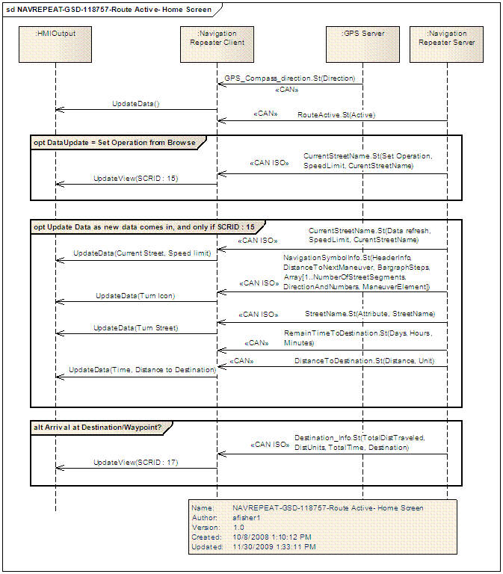

## NAVREPEAT-FUN-REQ-022829/A-Repeat Guidance, Route Active (TcSE ROIN-294105-1)

### Use Cases

#### NAVREPEAT-UC-REQ-022830/A-Repeat Guidance (TcSE ROIN-292750-1)

|  |  |
| --- | --- |
| **Actors** | User |
| **Pre-conditions** | Route is currently active. RH cluster is currently on the main Navigation home screen. |
| **Scenario Description** | The user selects repeat route guidance to hear the last guidance prompt again. |
| **Post-conditions** | Route is currently active. RH cluster is currently on the main Navigation home screen. |
| **List of Exception Use Cases** | N/A |
| **Interfaces** | Vehicle System Interface  G-HMI |

### Sequence Diagrams

#### NAVREPEAT-SD-REQ-022831/A-Repeat Guidance, Route Active (TcSE ROIN-118708-1)

Scenarios

Normal Usage

The user <selects repeat route guidance> via the cluster HMI to hear the last guidance prompt again.

Constraints

Pre-condition

Route is currently active.  RH cluster is currently on the main Navigation home screen.

Post-condition

Route is currently active.  RH cluster is currently on the main Navigation home screen.

Sequence Diagram

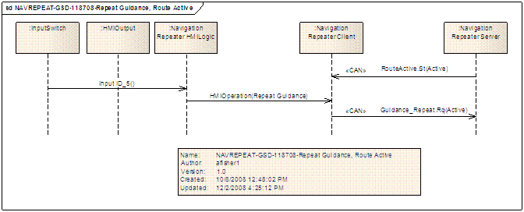

## NAVREPEAT-FUN-REQ-022832/A-Cancel Active Route (TcSE ROIN-294107-1)

### Use Cases

#### NAVREPEAT-UC-REQ-022833/A-Cancel Active Route (TcSE ROIN-292749-1)

|  |  |
| --- | --- |
| **Actors** | User |
| **Pre-conditions** | Navigation has an active route running. |
| **Scenario Description** | User cancels active route |
| **Post-conditions** | The current active route is cancelled. Cluster display returns to the Navigation- Route not active home screen. |
| **List of Exception Use Cases** | N/A |
| **Interfaces** | Vehicle System Interface  G-HMI |

### Sequence Diagrams

#### NAVREPEAT-SD-REQ-022834/A-Cancel Active Route (TcSE ROIN-150103-2)

Scenarios

Normal Usage

The user selects <Cancel Route> via the HMI.

Constraints

Pre-condition

Navigation has an active route running.

Post-condition

The current active route is cancelled.  Cluster display returns to the Navigation- Route not active home screen.

Sequence Diagram

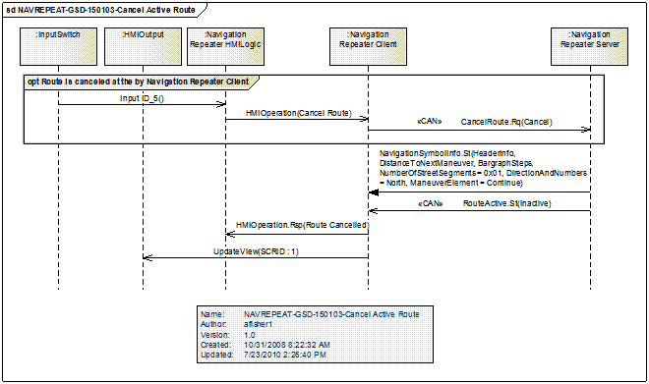

## NAVREPEAT-FUN-REQ-022835/A-Cancel Current Active Waypoint (TcSE ROIN-294109-1)

### Use Cases

#### NAVREPEAT-UC-REQ-022836/A-Cancel Waypoint (TcSE ROIN-292748-1)

|  |  |
| --- | --- |
| **Actors** | User |
| **Pre-conditions** | Navigation has an active route running, with at least one waypoint entered. |
| **Scenario Description** | User cancels waypoint |
| **Post-conditions** | The current active waypoint is cancelled. Cluster display returns to the Navigation- Route active home screen and continues the active route. |
| **List of Exception Use Cases** | N/A |
| **Interfaces** | Vehicle System Interface  G-HMI |

### Sequence Diagrams

#### NAVREPEAT-SD-REQ-022837/A-Cancel Current Active Waypoint (TcSE ROIN-150110-1)

Scenarios

Normal Usage

The user selects <Cancel current waypoint> via the cluster HMI.

Constraints

Pre-condition

Navigation has an active route running, with at least one waypoint entered.

Post-condition

The current active waypoint is cancelled.  Cluster display returns to the Navigation- Route active home screen and continues the active route.

Sequence Diagram

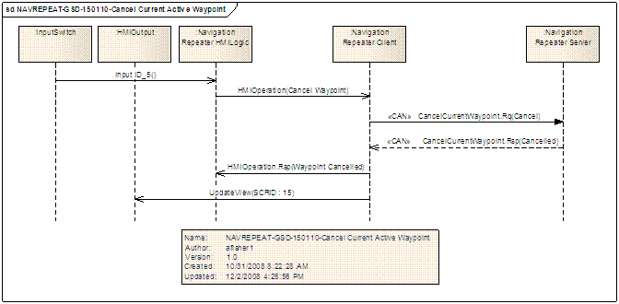

## NAVREPEAT-FUN-REQ-092269/A-Detailed Intersection Widgit

Detailed Intersection Widgit

### Use Cases

Use Cases

#### NAVREPEAT-UC-REQ-092268/A-Detailed Intersection Widgit

|  |  |
| --- | --- |
| **Actors** | System |
| **Pre-conditions** | Embedded navigation route active.  Vehicle equipped with an Electronic Horizon rich map. |
| **Scenario Description** | The vehicle approaches a manuver. |
| **Post-conditions** | The HUD or equivalent technology shall render a representation of that manuver. |
| **List of Exception Use Cases** |  |
| **Interfaces** | CAN, GHMI |

### Requirements

Requirements

#### EH-FUR-REQ-092267/A-Detailed Intersection Widgit

Given NAV Repeater conformance level of 2 or greater, the expansion of the most probable path must trigger UpcomingStreetName.St signal for each new stub identified. See NAV Repeater feature for UpcomingStreetName.St definition.

# Appendix: Reference Documents

|  |  |
| --- | --- |
| Reference # | Document Title |
| 1 |  |
| 2 |  |
| 3 |  |
| 4 |  |
| 5 |  |